CPE 325: Intro to Embedded Computer System

**Lab02**

**Output specifiers, Array manipulation, Data-Types**

**Submitted by**: Nolan Anderson

**Date of Experiment**: _____________________

**Report Deadline**: 09/07/2020

# Introduction

Lab two is a overview of how to output data correctly, a focus on the different data types, and array / matrix multiplication. Problem one has you output the data type, its size, along with its minimum and maximum value. Need to understand how to include headers, use output specifiers, and printf. The third problem covers a simple for loop to find the dot product of two, minimum 5 element array’s.

# Theory

# Results & Observation

Copy the question from the assignment here:

## Flow Charts:

## Results Screenshots/Pictures:

Lab 2 Problem 1 console output:

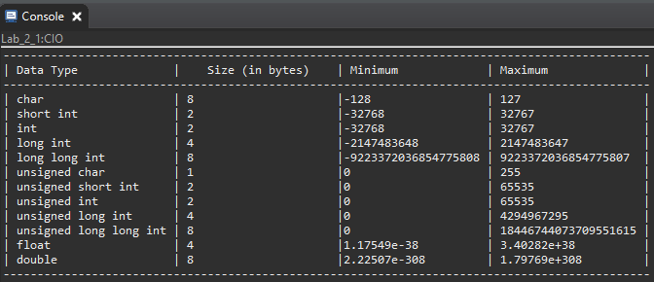

Lab 2, Problem 3 console output:

## 

## Observations:

# Conclusion

Write your conclusion. (Explain what you have learnt and issues you faced)

Link to your video recordings/demo.

# Appendix

## Appendix 1

|  |
| --- |
| /*------------------------------------------------------------------------------  * Student: Nolan Anderson  * Program: Lab_2_1.c  * Date: Aug 21, 2121  * Input: None  * Output: Prints the sizes of common c data types  * Description: This c program prints the sizes and ranges of common data types:  * char, short int, int, long int, long long int, unsigned char,  * unsigned short int, unsigned int, unsigned  long int, unsigned long long int, float, and double.  *-----------------------------------------------------------------------------*/  **#include** <msp430.h>  **#include** <stdio.h>  **#include** <limits.h>  **#include** <float.h>  **int** **main**()  {  WDTCTL = WDTPW + WDTHOLD; // Stop WatchDogTimer  **int** unsignedmin = 0;  **printf**("-----------------------------------------------------------------------------------------------\n");  **printf**("| Data Type | Size (in bytes) | Minimum | Maximum |\n");  **printf**("-----------------------------------------------------------------------------------------------\n");  **printf**("| char | %d |%-21hhi| %-21hhi|\n", CHAR_BIT, SCHAR_MIN, SCHAR_MAX);  **printf**("| short int | %d |%-21hd| %-21hd|\n", **sizeof**(**short** **int**), SHRT_MIN, SHRT_MAX);  **printf**("| int | %d |%-21d| %-21d|\n", **sizeof**(**int**), INT_MIN, INT_MAX);  **printf**("| long int | %d |%-21ld| %-21ld|\n", **sizeof**(**long** **int**), LONG_MIN, LONG_MAX);  **printf**("| long long int | %d |%-21lld| %-21lld|\n", **sizeof**(**long** **long** **int**), LLONG_MIN, LLONG_MAX);  **printf**("| unsigned char | %d |%-21hhu| %-21hhu|\n", **sizeof**(**unsigned** **char**), CHAR_MIN, UCHAR_MAX);  **printf**("| unsigned short int | %d |%-21hu| %-21hu|\n", **sizeof**(**unsigned** **short** **int**), unsignedmin, USHRT_MAX);  **printf**("| unsigned int | %d |%-21u| %-21u|\n", **sizeof**(**unsigned** **int**),unsignedmin, UINT_MAX);  **printf**("| unsigned long int | %d |%-21u| %-21lu|\n", **sizeof**(**unsigned** **long** **int**), unsignedmin, ULONG_MAX);  **printf**("| unsigned long long int | %d |%-21u| %-21llu|\n", **sizeof**(**unsigned** **long** **long** **int**), unsignedmin, ULLONG_MAX);  **printf**("| float | %d |%-21.2E| %-21.2E|\n", **sizeof**(**float**), -FLT_MAX, FLT_MAX);  **printf**("| double | %d |%-21g| %-21g|\n", **sizeof**(**double**), -DBL_MAX, DBL_MAX);  **printf**("-----------------------------------------------------------------------------------------------\n");  **return** 0;  } |

## Appendix 2

Your next code goes here, if any.

|  |
| --- |
| /*------------------------------------------------------------------------------  * Student: Nolan Anderson  * Program: Lab_2_3.c  * Date: Aug 21, 2121  * Input: None  * Output: Takes the dot product of two minimum 5 element arrays  * Description: This program takes in two input arrays and performs a dot  * product of the two. Then it outputs the dot product of the two  * array's.  *-----------------------------------------------------------------------------*/  **#include** <msp430.h>  **#include** <stdio.h>  **int** **main**()  {  WDTCTL = WDTPW + WDTHOLD;  **int** array[] = {-1, 2, 5, 3, -5, 6}; // First array  **int** array2[] = {-7, 8, 23, 13, 23, 28}; // Second Array  **int** product = 0; // Product initializer  **int** i = 0; // Loop Initializer  **printf**("Input Array X: ["); // Printing out first statement  **for**(i = 0; i < 6; i++) // Loop through the values  {  product = product + array[i] * array2[i]; // Perform the dot product on the two arrays  **printf**(" %d", array[i]); // Output first array values  }  **printf**("]\nInput Array Y: ["); // Output start for second array  **for**(i = 0; i < 6; i++)  {  **printf**(" %d", array2[i]); // Output values for second array  }  **printf**("]\nDot product is: %d", product); // Last line to output product.  **return** 0;  } |